Shirdora Fav Recipes

### Executive Summary:

**This recipe app is a digital platform that provides users with a convenient and accessible way to discover, organize, and follow cooking instructions for various dishes. The primary purpose of this app is to offer a curated collection of recipes I have made and want to try, including recipes I have created, including ingredients and step-by-step cooking instructions. Users can typically search for recipes based on preferences, dietary restrictions, or specific ingredients, making the app a tool for novice and experienced cooks.**

### Target Audience:

**The target audience for my app comprises young adults and college students who need creative and affordable ideas for meals.**

### Key Features:

**The features this app will have are:**

* **Be able to save specific recipes**
* **Get a recipe of the month**
* **Be able to search for specific recipes**
* **Filter by dietary restrictions and ingredients**

### User Interface (UI) Design:

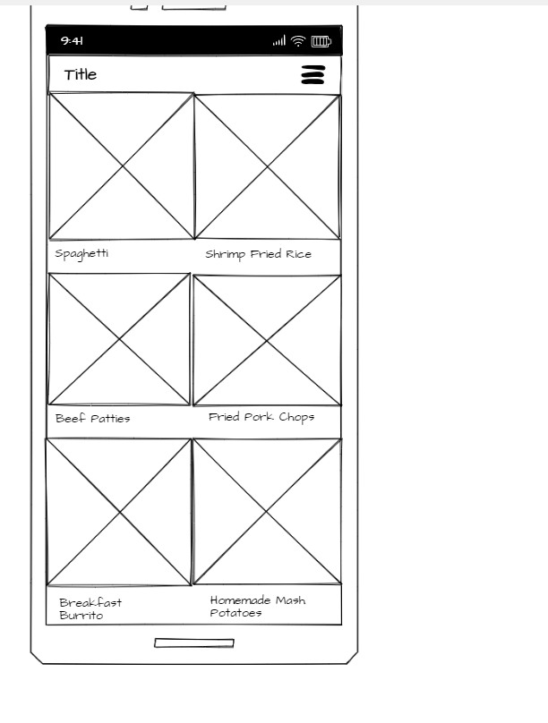

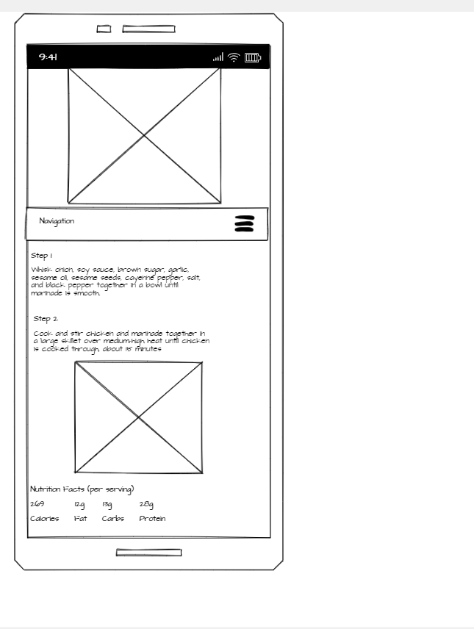

Conclusion:

In conclusion, my recipe app aims to be a go-to digital kitchen companion, providing users with a seamless and enjoyable cooking experience. With a focus on young adults and college students, the app caters to those seeking creative and affordable meal ideas. By offering features like the ability to save favorite recipes, a monthly highlighted recipe, and search and filtering options based on dietary restrictions and ingredients, the app aims to streamline the cooking process and inspire culinary exploration. Intending to make cooking more accessible and enjoyable for both novices and experienced cooks alike, the recipe app aspires to become an indispensable tool in the kitchen of the target audience.